DEPLOYING A THREE-TIER APPLICATION IN KUBERNETES

PROJECT_URL https://github.com/mayurpandit25/EasyCRUD.git
1. CREATE RDS DATABASE
- username: admin
- password: admin123
- database: student_db
- Public Access: Yes
- Sg: 3306 (MYSQL/Aurora)
2. CLONE PROJECT
- git clone https://github.com/mayurpandit25/EasyCRUD.git
- cd EasyCRUD

3. BUILD BACKEND
1. cd backend/src/main/resources/
2. vim application.properties
- username: admin
- password: admin123
- database_endpoint: <endpoint>
3. docker build -t backend .
4.docker tag backend mayurpandit25/cbz-backend:latest
5.docker push mayurpandit25/cbz-backend:latest

6.vim backend-deployment.yaml
apiVersion: apps/v1
kind: Deployment
metadata:
name: backend
labels:
app: backend
spec:
replicas: 2
selector:
matchLabels:
app: backend
template:
metadata:
labels:
app: backend
spec:
containers:
- name: backend
image: mayurpandit25/cbz-backend:latest
ports:
- containerPort: 8080
7.vim backend-svc.yaml
apiVersion: v1
kind: Service
metadata:
name: backend-svc
spec:
type: NodePort
selector:
app: backend
ports:
- port: 8080
targetPort: 8080

8.kubectl apply -f backend-deployment.yaml
9.kubectl apply -f backend-svc.yaml
10.kubectl get pods
11.kubectl get svc -o wide
12.kubectl get nodes -o wide

13.curl <node-ip>:<node-port>/api
14.http://13.204.225.64:31082/api ----------> on browser

4. BUILD FRONTEND
- cd frontend
- vim .env
VITE_API_URL=http://13.204.225.64:31082/api
- docker build -t frontend .
- docker tag frontend mayurpandit25/cbz-frontend:latest
- docker login
- docker push mayurpandit25/cbz-frontend:latest
- vim frontend-deployment.yaml
apiVersion: apps/v1
kind: Deployment
metadata:
name: frontend
labels:
app: frontend
spec:
replicas: 3
selector:
matchLabels:
app: frontend
template:
metadata:
labels:
app: frontend
spec:
containers:
- name: frontend
image: mayurpandit25/cbz-frontend:latest
ports:
- containerPort: 80

8. vim frontend-svc.yaml
apiVersion: v1
kind: Service
metadata:
name: frontend-svc
spec:
type: LoadBalancer
selector:
app: frontend
ports:
- port: 80
targetPort: 80

9. kubectl apply -f frontend-deployment.yaml
10.kubectl apply -f frontend-svc.yaml
11.kubectl get pods
12.kubectl get svc -o wide

5. COPY LOAD-BALANCER DNS
- <frontend-svc-xxxxx.ap-south-1.elb.amazonaws.com> -----> hit on web
- check the security-group --> 80

DEPLOYING A THREE-TIER APPLICATION IN EKS WITH
NGINX-INGRESS + DOMAIN
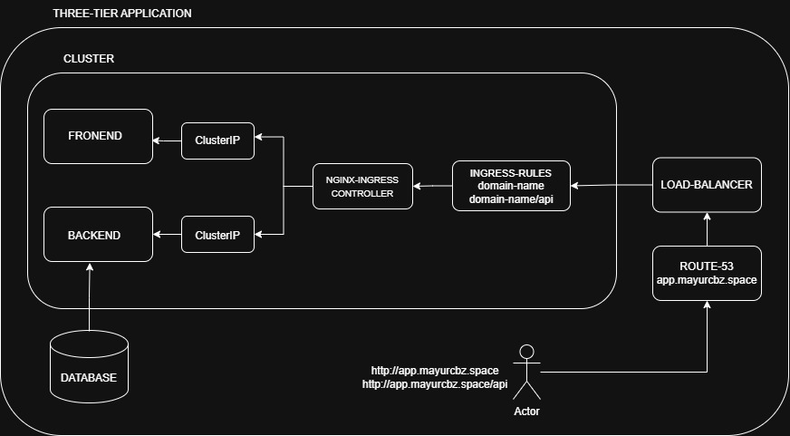

PROJECT_URL https://github.com/mayurpandit25/EasyCRUD.git
1. CREATE RDS DATABASE
- username: admin
- password: admin123
- database: student_db
- Public Access: Yes
- Sg: 3306 (MYSQL/Aurora)
2. CLONE PROJECT
- git clone https://github.com/mayurpandit25/EasyCRUD.git
- cd EasyCRUD

3. BUILD BACKEND
1. cd backend/src/main/resources/
2. vim application.properties
- username: admin
- password: admin123
- database_endpoint: <endpoint>
3. docker build -t backend .
4.docker tag backend mayurpandit25/cbz-backend:latest
5.docker push mayurpandit25/cbz-backend:latest

6.vim backend-deployment.yaml
apiVersion: apps/v1
kind: Deployment
metadata:
name: backend
labels:
app: backend
spec:
replicas: 2
selector:
matchLabels:
app: backend
template:
metadata:
labels:
app: backend
spec:
containers:
- name: backend
image: mayurpandit25/cbz-backend:latest
ports:
- containerPort: 8080
7.vim backend-svc.yaml
apiVersion: v1
kind: Service
metadata:
name: backend-svc
spec:
type: ClusterIP
selector:
app: backend
ports:
- port: 8080
targetPort: 8080

8.kubectl apply -f backend-deployment.yaml
9.kubectl apply -f backend-svc.yaml
10.kubectl get pods
11.kubectl get svc

4.TEST BACKEND
- kubectl get svc
- kubectl port-forward svc/backend-svc 8081:8080 --address=0.0.0.0 &
- http://<EC2-PUBLIC-IP>:8081/api

5. BUILD FRONTEND
- cd frontend
- vim .env
VITE_API_URL=/api
- docker build -t frontend .
- docker tag frontend mayurpandit25/cbz-frontend:latest
- docker login
- docker push mayurpandit25/cbz-frontend:latest
- vim frontend-deployment.yaml
apiVersion: apps/v1
kind: Deployment
metadata:
name: frontend
labels:
app: frontend
spec:
replicas: 3
selector:
matchLabels:
app: frontend
template:
metadata:
labels:
app: frontend
spec:
containers:
- name: frontend
image: mayurpandit25/cbz-frontend:latest
ports:
- containerPort: 80

- vim frontend-svc.yaml
apiVersion: v1
kind: Service
metadata:
name: frontend-svc
spec:
type: ClusterIP
selector:
app: frontend
ports:
- port: 80
targetPort: 80

9. kubectl apply -f frontend-deployment.yaml
10.kubectl apply -f frontend-svc.yaml
11.kubectl get pods
12.kubectl get svc

6. TEST FRONTEND
- kubectl get svc
- kubectl port-forward svc/frontend-svc 8080:80 --address=0.0.0.0 &
- http://<EC2-PUBLIC-IP>:8080

7. INSTALL NGINX-INGRESS CONTROLLER
- kubectl apply -f https://raw.githubusercontent.com/kubernetes/ingress-nginx/main/deploy/static/provider/aws/deploy.yaml
- kubectl get pods -n ingress-nginx
- kubectl get svc -n ingress-nginx
- vim ingress.yaml
apiVersion: networking.k8s.io/v1
kind: Ingress
metadata:
name: app-ingress
spec:
ingressClassName: nginx
rules:
- host: app.mayurcbz.space
http:
paths:
- path: /
pathType: Prefix
backend:
service:
name: frontend-svc
port:
number: 80
- path: /api
pathType: Prefix
backend:
service:
name: backend-svc
port:
number: 8080

- kubectl apply -f ingress.yaml
- kubectl get ingress

8. CONFIGURE ROUTE53
- create a hosted zone (mayurcbz.space)
- click on created-hosted zone (mayurcbz.space)
- create a record
- record-name: app
- record-type: A
- alias
  - choose-endpoint: Alias to network load-balancer
  - choose-region: ap-south-1
  - choose load-balancer: Network-Load-Balancer
- create a record

Note:
- Add these hosted-zone nameservers on the hostinger domain-name

- OPEN APPLICATION
Your Frontend Application
- http://app.mayurcbz.space

Your Backend Application
2. http://app.mayurcbz.space/api

